**Step1: Accessing Colab**

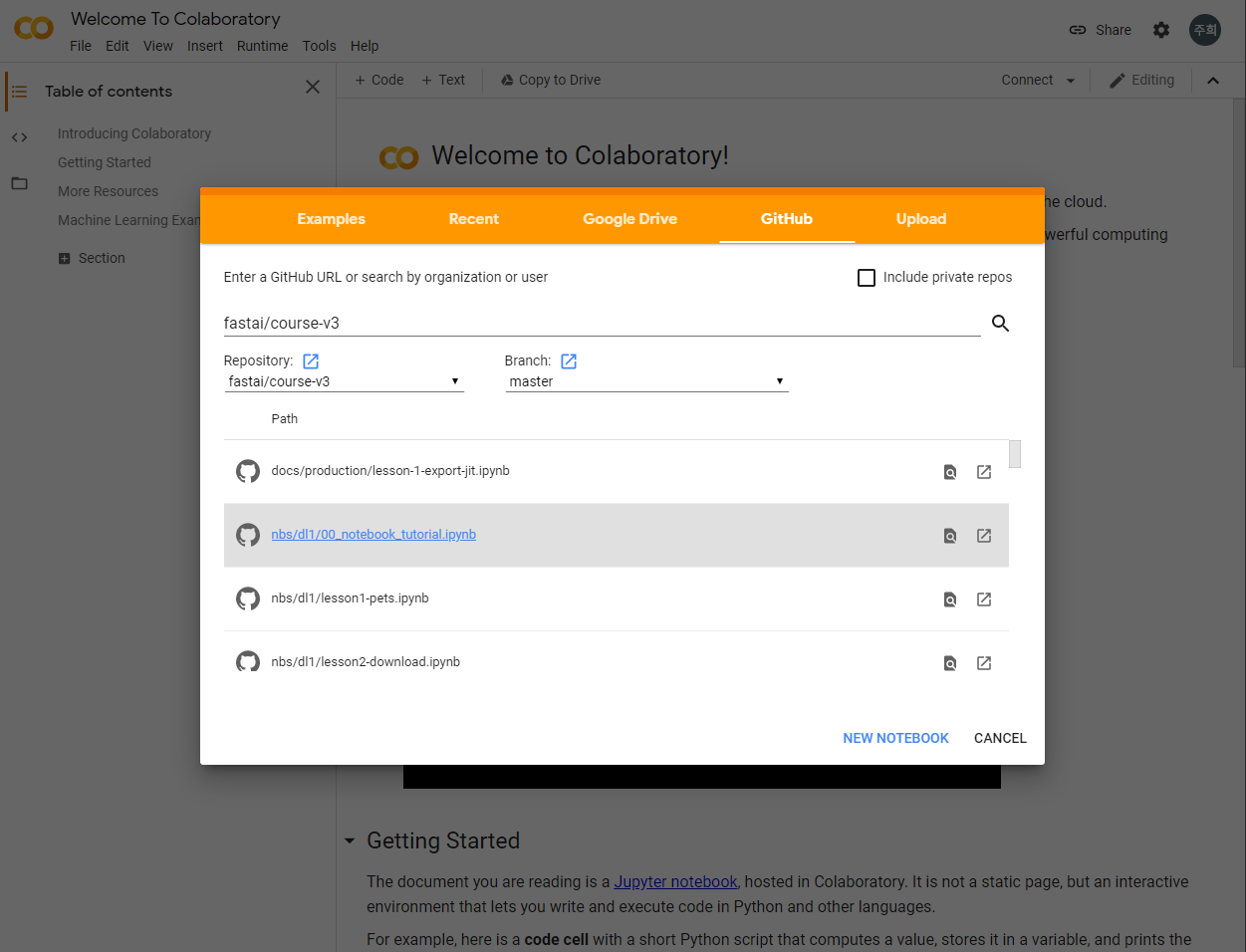

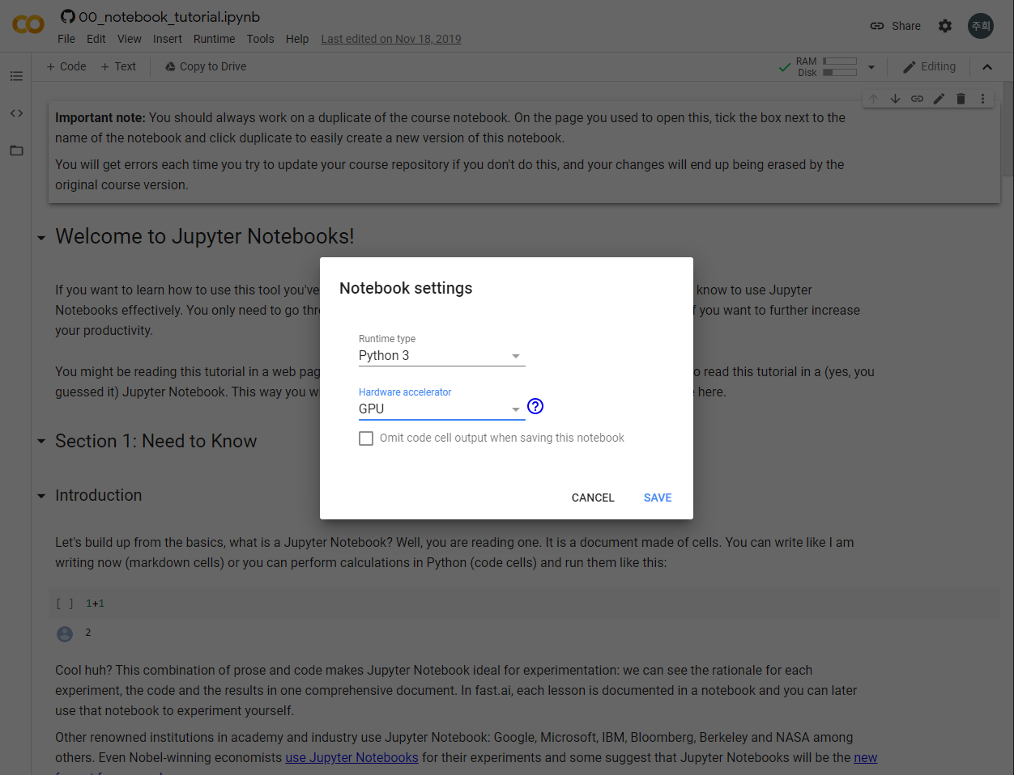

**Step 2: Configuring my notebook instance**

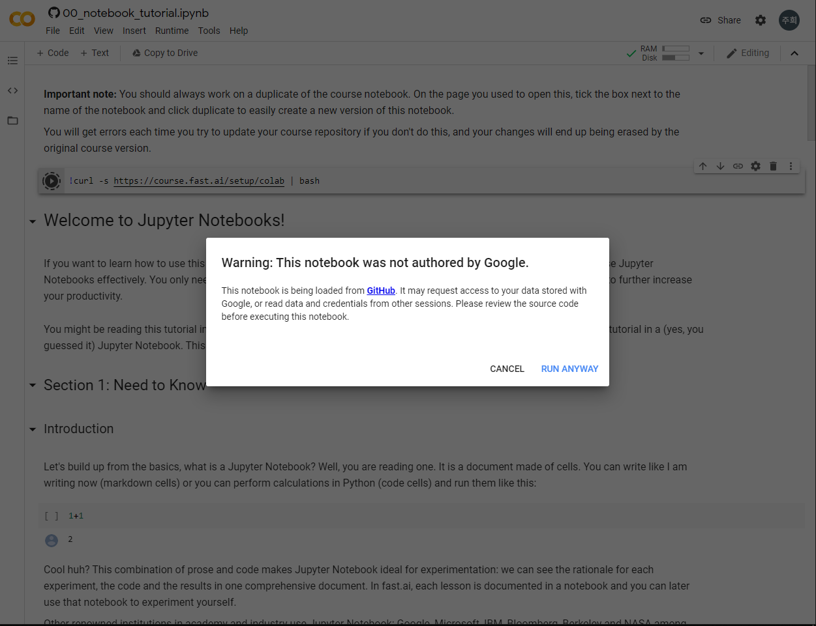



**Step 3: Saving my notebook**

And this is the copied notebook.

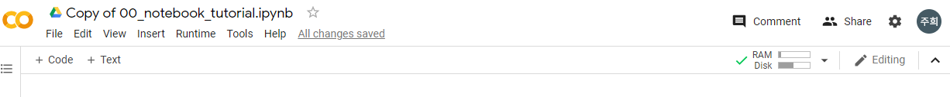

**Step 4: Saving my data files**

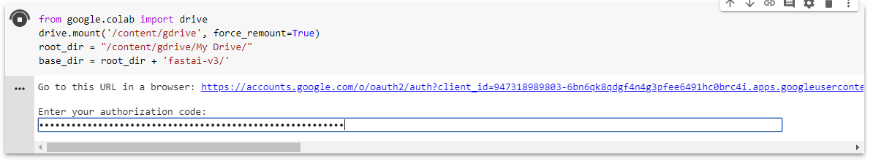

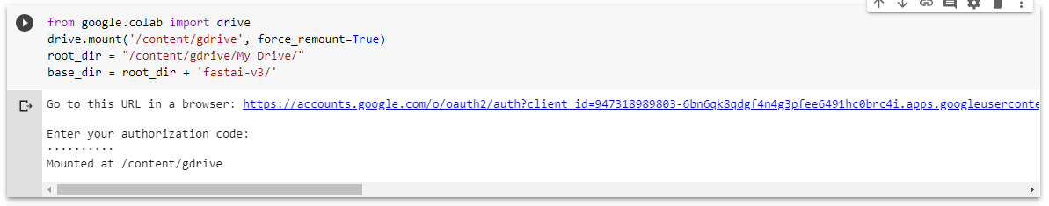

**… Below is the result of every executed codes.**







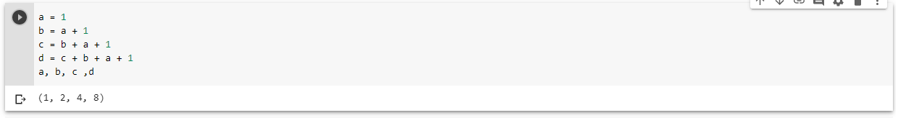

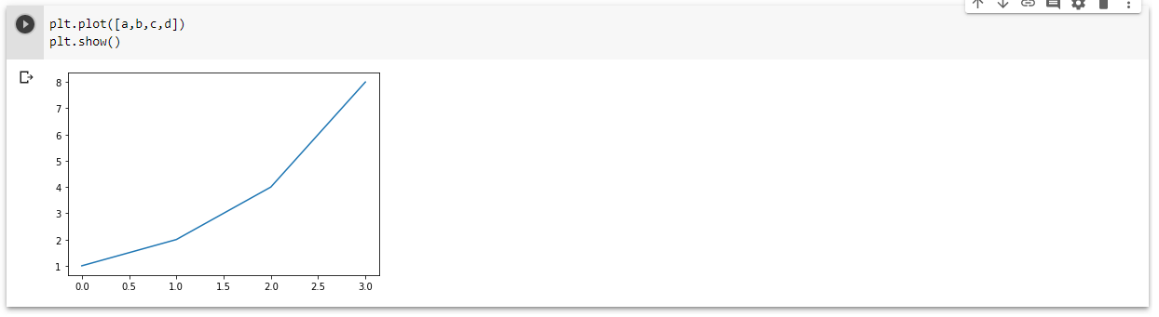

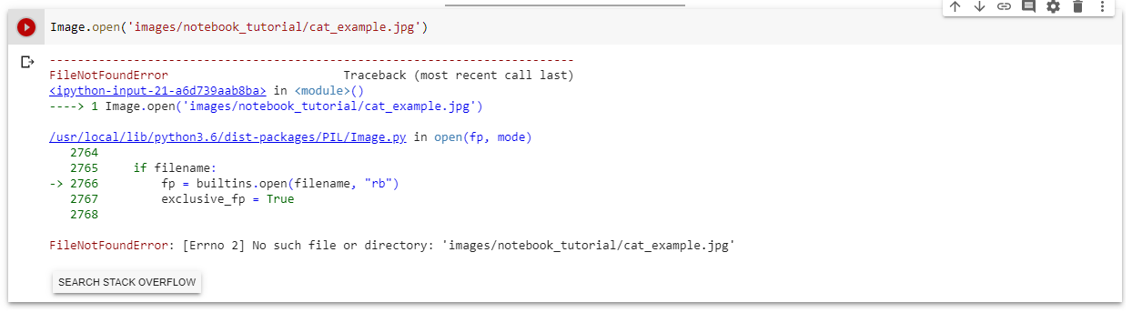

So I made new folders in my google drive, downloaded a cat picture, and saved it in that new folder. Then, I changed the code like this.

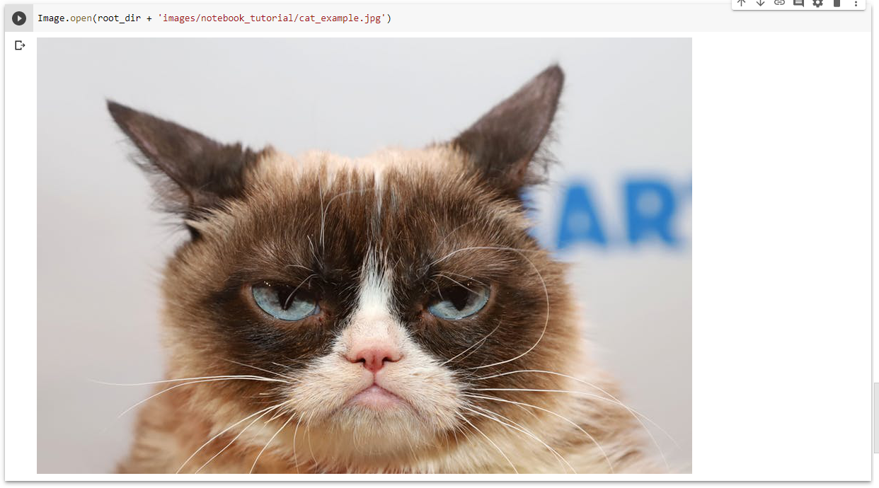



This shows the definition and docstring for ImageDataBunch.



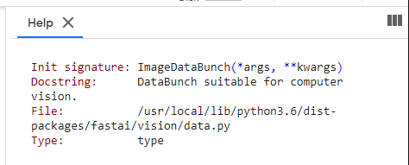

This shows the source code for ImageDataBunch.



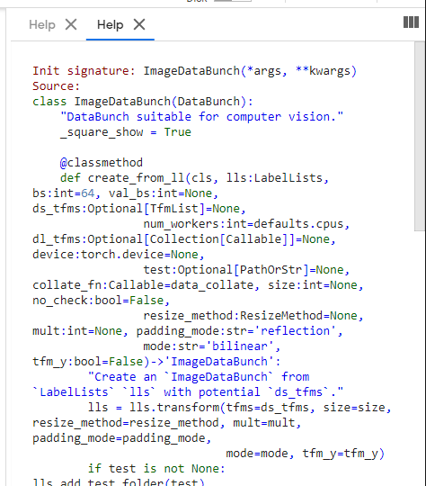

This shows the definition, docstring and links to the documentation of ImageDataBunch.

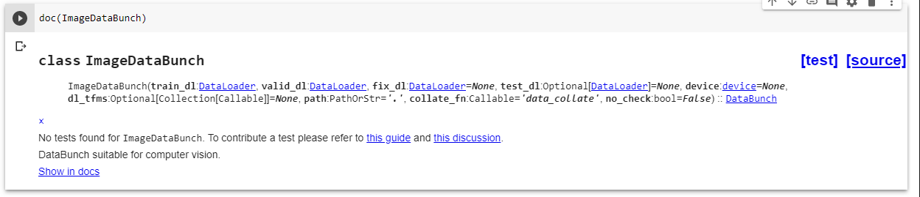





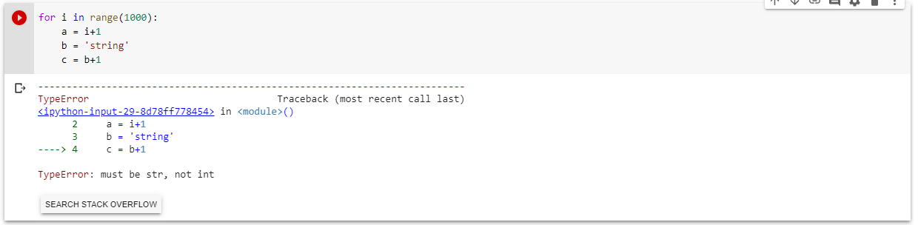

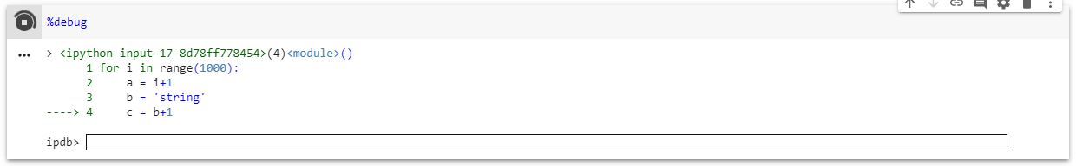

I could get help or results after entering commands.

